Notable Quotes
Overall, generative AI is in use (by the respondent or a colleague) in 30.7% of SMEs, on average across the countries surveyed.1 60.5% report having heard of generative AI but that it is not in use, while 8.8% report not having heard of generative AI.
https://www.oecd.org/content/dam/oecd/en/publications/reports/2025/11/generative-ai-and-the-sme-workforce_83bafdfb/2d08b99d-en.pdf

Note: Low adoption of AI still in 2025 in SMEs, so loads of gen AI use to come.

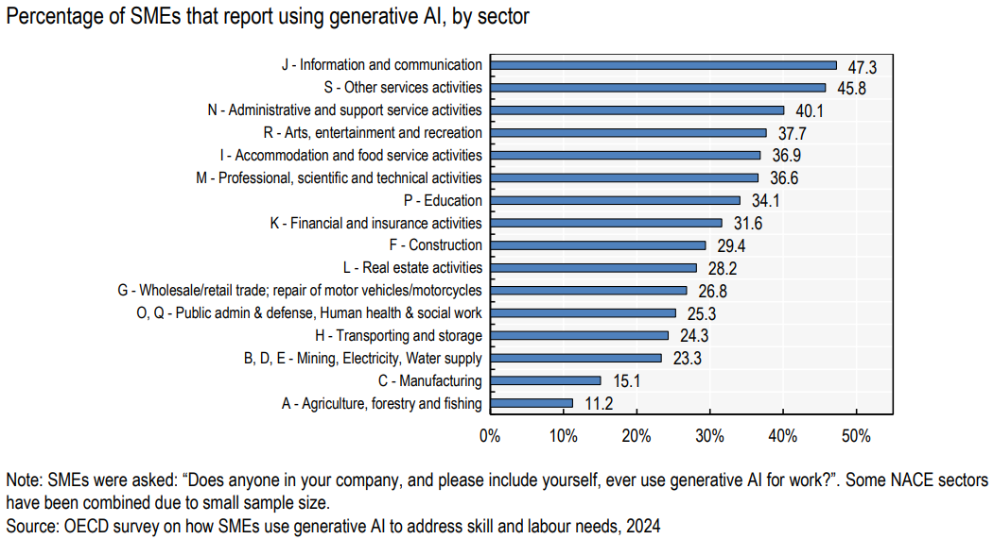

Medium-sized companies (50 to 249 employees) are more likely to use generative AI than small companies (10 to 49 employees) and micro businesses (<10 employees).
